 [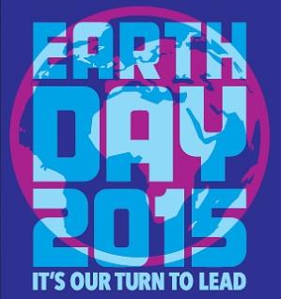](http://translate.googleusercontent.com/translate_c?depth=1&hl=ro&prev=search&rurl=translate.google.ro&sl=en&u=http://earthday.sevenly.org/?utm_source=website&utm_medium=EDN&utm_campaign=EDN_Website_ED2015&usg=ALkJrhjXRLDz9bAhCzz3pe8b2JrvdH_EiQ)

**ZIUA PĂMÂNTULUI 2015**

